**STATIC WEBSITE HOSTING**

**Abstract:**

The project aims to demonstrate the implementation of a static web page hosting solution using Amazon Simple Storage Service (S3). Amazon S3 provides a scalable, secure, and cost-effective object storage solution, making it well-suited for hosting static websites. This project guides users through the process of creating an S3 bucket, uploading static web page files, and configuring the necessary settings for web hosting.

Upon completion, the static website becomes accessible through a public endpoint provided by S3. This project serves as a foundational guide for users seeking a straightforward and efficient method for hosting static websites on AWS infrastructure, showcasing the simplicity and versatility of Amazon S3 for web hosting purposes. Users can further extend the project by incorporating additional features like custom domains, SSL certificates, and content delivery networks based on their specific needs.

**Objective**:

The primary objective of this project is to deploy a secure and scalable static web hosting solution on Amazon Simple Storage Service (S3) for an online book shopping web page. This deployment aims to showcase the simplicity and effectiveness of using AWS S3 to host static content, including HTML and CSS files, for an e-commerce application.

The specific objectives include:

* Create an S3 bucket to store and serve the static files of the online book shopping web page.
* Upload files along with any necessary assets (images, etc.) to the S3 bucket.
* Configure the S3 bucket for static website hosting, ensuring proper indexing and error handling.
* Implement a secure and granular access control policy for the S3 bucket, allowing public read access to web content while adhering to best practices for security.
* Provide users with a practical example of hosting an online book shopping web page on AWS S3, emphasizing ease of deployment and maintenance.

**Resources Required:**

1. AWS Management Console
2. Amazon S3 Bucket
3. Static Website Files
4. Amazon Route 53 (optional)
   * + If you want to use a custom domain for your website, you can use Amazon Route 53 to register a domain and configure DNS settings.
5. Content Delivery Network (CDN) - Amazon CloudFront (optional)
   * + For improved performance and global content distribution, you can configure Amazon CloudFront as a CDN for your static website.
6. Backup and Versioning (optional)
   * + Consider implementing versioning and backup strategies for your S3 bucket to protect against accidental data loss or modifications.

**Key Steps To Be Followed:**

Amazon S3 Bucket:

* Create an S3 bucket to store and serve static files for your web page.

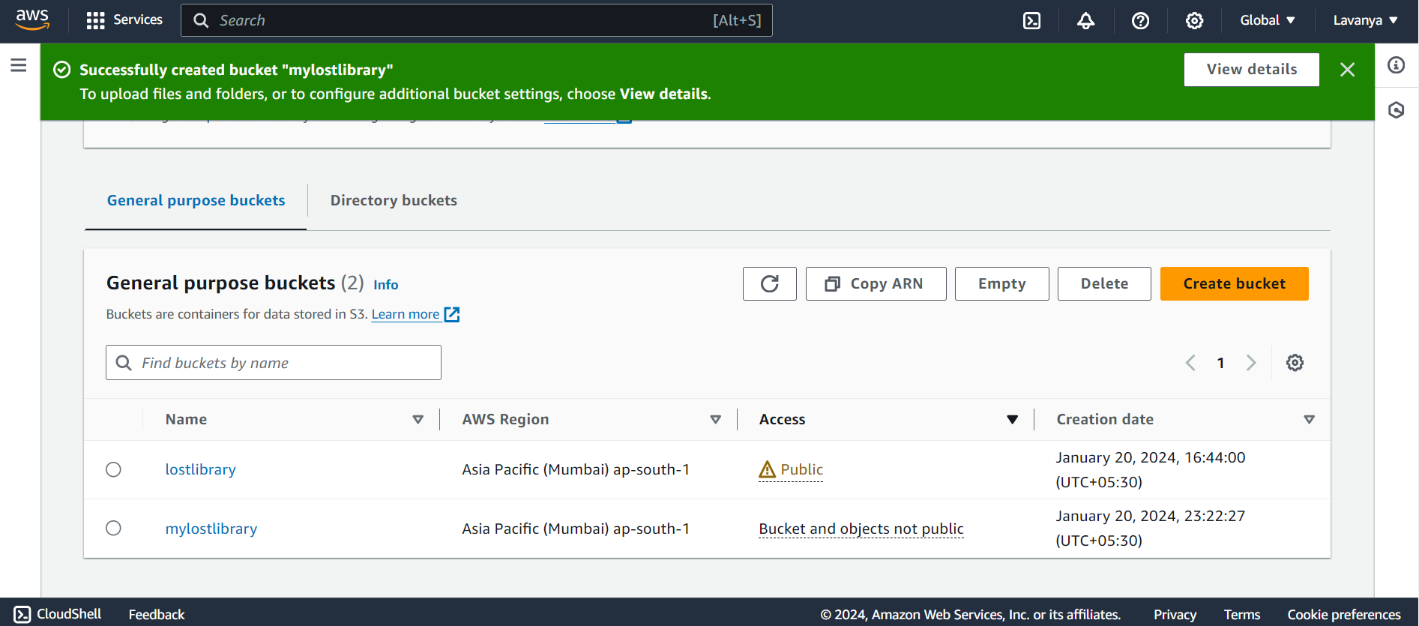

Enable Static Hosting:

* Enable host a static website option as shown in the picture below.

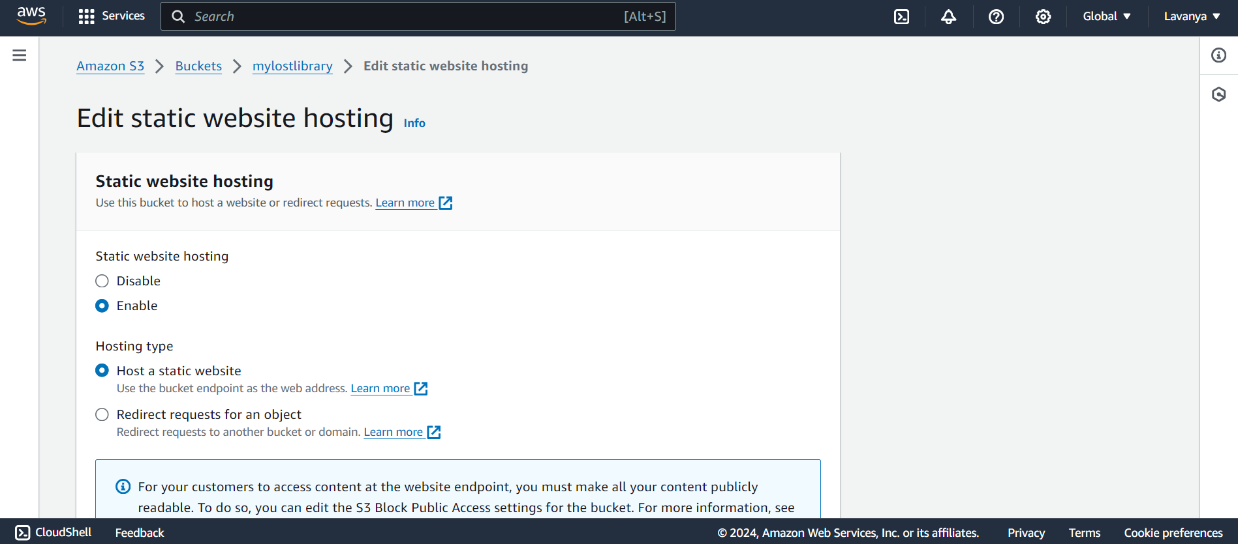

Amazon S3 Permissions:

* Configure access permissions for your S3 bucket, including a bucket policy that allows public read access to the necessary files.

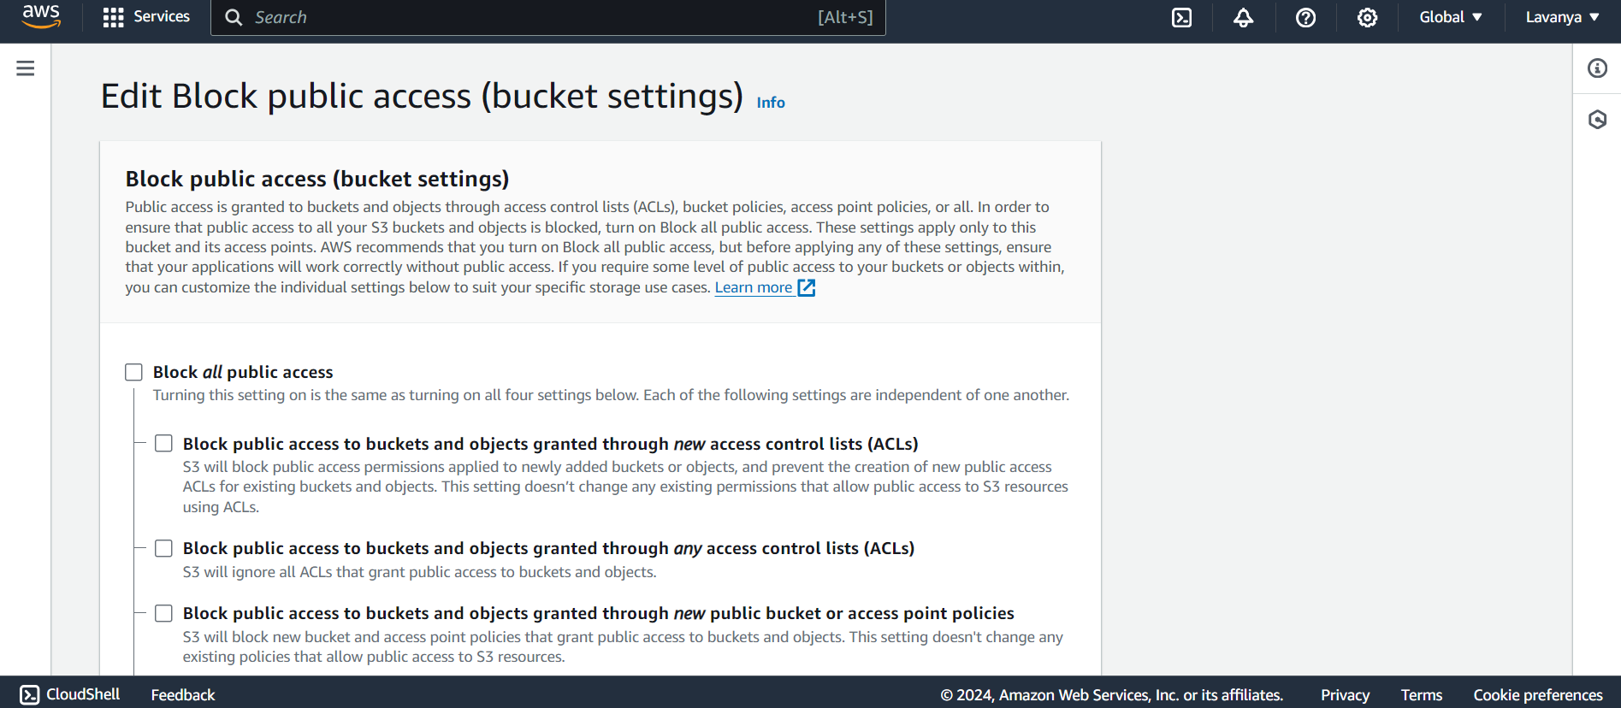

Amazon S3 Bucket Policy:

* In AWS (Amazon Web Services), a policy is a set of permissions that define the actions allowed or denied on AWS resources.

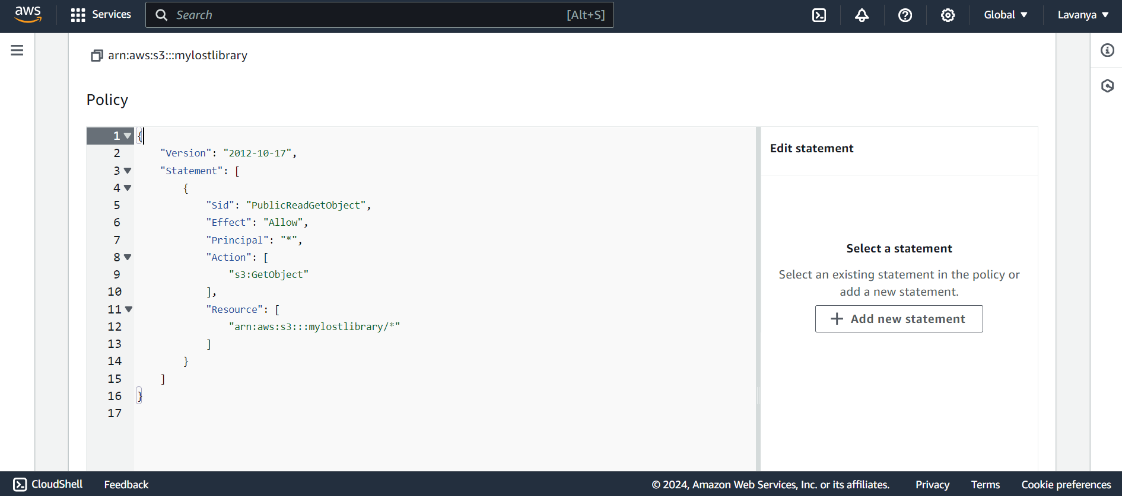

Policy:

{

"Version": "2012-10-17",

"Statement": [

{

"Sid": "PublicReadGetObject",

"Effect": "Allow",

"Principal": "*",

"Action": [

"s3:GetObject"

],

"Resource": [

"arn:aws:s3:::mylostlibrary/*"

]

}

]

}

Static Website Files:

* Upload HTML, CSS and any other assets (images, etc.) that make up your static website.

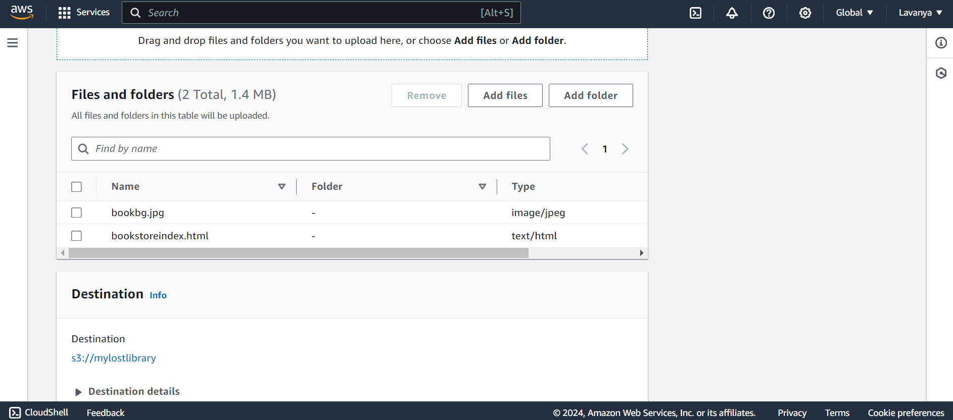

Demonstration:

* By accessing the URL you can demonstrate your static web site in the browser.

